Website Planning Document

# Site Name

A Likely Story

# Site Purpose

To sell books

# Target Audience

Readers

# Sitemap

Home, About, Locations, Books, Ebooks, Sales, Toys & Games, Movies & Music, Gift



# Color Scheme

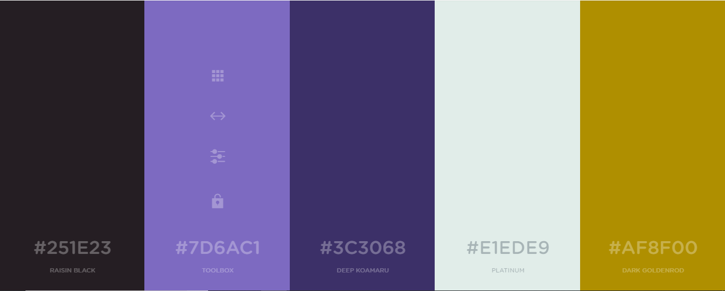

# Typography

HTML: <link href="https://fonts.googleapis.com/css?family=**Montserrat**" rel="stylesheet">

CSS: font-family: 'Montserrat', sans-serif;

Bit at the top: number + email + social, join & free shipping, coupon, account + locations

Header: Logo, search, account, wish-list, cart

Nav: Home, About, Locations, Books, Ebooks, Sales, Toys & Games, Movies & Music, Gift

Body: Page hero, new/sales/ads/exclusives, < ||| >, gift guide link, categories, boxed sets, video

1. Today's Top Sellers
2. What Every Kid Wants: Get the Top Toys Before They're Gone!
3. New Releases
4. Celebrating 20 Years of Harry Potter Magic!
5. Our Favorite Funko POPs!
6. Coming Soon: Pre-Order the Next Bestseller Today!

Footer: copyright, email sign-up, join club, social, logo, abbreviated nav